CLICK. PLAY. LEARN!  PREP ICT LESSON PLAN  A practical planning template for 5–7-year-old ESL learners | 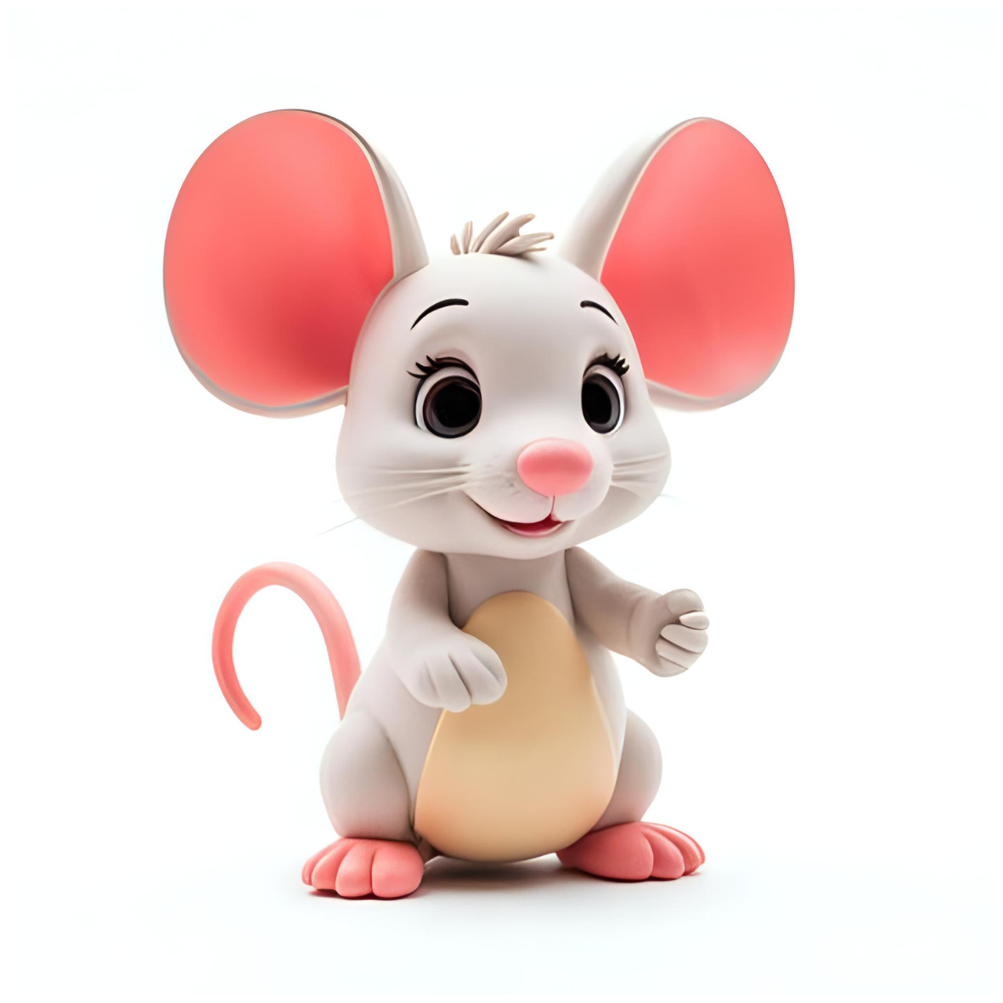

Lesson No. |  | Lesson Title
Class |  | Date |  | Duration
Teacher |  | Grouping | ☐ Whole class ☐ Pairs ☐ Small group ☐ Individual

1 | LEARNING FOCUS  Begin with the curriculum goal, not the activity.
Giggle Goal  (I can...) | ________________________________________________
Curriculum links | UK Computing: ____________________________ PYP/ATL: ____________________________
Skill focus | ☐ MacBook basics ☐ Mouse ☐ Trackpad ☐ Keyboard ☐ Internet safety ☐ Review
Prior learning / next lesson | ________________________________________________

2 | KEY LANGUAGE AND MAC TERMINOLOGY  Use the same child-friendly words during modelling and practice.
Key vocabulary | Use on Mac | Exact child-friendly instruction

3 | RESOURCES AND PREPARATION  Prepare the digital route and the classroom routine before students arrive.
Website lesson / activity  ________________________________________________ | Video / story / demonstration  ________________________________________________
Teacher resources / printable  ________________________________________________ | Assessment or observation tool  ________________________________________________
MacBooks, logins and Wi-Fi checked  ________________________________________________ | Files or links opened in advance  ________________________________________________
Other preparation  ________________________________________________ | Backup plan if technology fails  ________________________________________________
TEACHING SEQUENCE, SUPPORT AND ASSESSMENT

4 | LESSON SEQUENCE  Show → Guide → Release → Reflect
Phase | Time | Teacher actions | Student actions | Resources | Check for understanding
1. Welcome & ICT routine | 5 min
2. Watch / Model | 5–10 min
3. Guided practice | 10 min
4. Independent practice / game | 15 min
5. Reflect & close | 5 min

5 | SUPPORT EVERY LEARNER  Identify the barrier, then choose the smallest useful support.
Possible language / communication barrier  ________________________________________________ | Visual or language support  ________________________________________________
Possible device / confidence barrier  ________________________________________________ | Fine-motor, device or confidence support  ________________________________________________
Support for students needing more practice  ________________________________________________ | Extension for students ready to move on  ________________________________________________
Partner or Tech Buddy plan  ________________________________________________ | How independence will be encouraged  ________________________________________________

6 | OBSERVATION AND ASSESSMENT  Record what students do, not what you think they understand.
I can statement to observe | ________________________________________________
Observable evidence | ________________________________________________
Evidence collected | ☐ Tracker rating ☐ Teacher note ☐ Screenshot ☐ Student product ☐ Exit check
Participation and attitude | ☐ Engaged ☐ Willing to try ☐ Asks for help appropriately ☐ Uses equipment responsibly
NS – Needs Support | S – Satisfactory | G – Good | E – Excellent
What would this look like in this lesson? | What would this look like in this lesson? | What would this look like in this lesson? | What would this look like in this lesson?

7 | POST-LESSON REFLECTION  Use the evidence to improve the next lesson.
What worked well?  ________________________________________________  ________________________________________________ | Which students need follow-up support?  ________________________________________________  ________________________________________________
What will I adjust next time?  ________________________________________________  ________________________________________________ | What is the next skill or lesson?  ________________________________________________  ________________________________________________

8 | REPORTING NOTE  Turn one clear observation into a parent-friendly comment.
Skill | What can the student do?  ________________________________________________
Evidence | What did you observe?  ________________________________________________
Next step | What should the student practise next?  ________________________________________________

